**Module-2 ( CSS and CSS-3)**

**Question** 1. What are the benefits of using CSS?

**Answer.** CSS separates the content and design (visual appearance) of html document, hence it is easier to make any updates in design or in content. CSS helps to apply uniform styles across multiple web pages.

**Question** 2. What are the disadvantages of CSS?

**Answer.** there are some drawbacks to CSS. It can be complex for beginners, leading to a steep learning curve. Compatibility issues with different web browsers can also arise. Overusing CSS can potentially slow down a website's performance.

**Question** 3. What is the difference between CSS2 and CSS3?

**Answer.**CSS3 is the latest version, which has many new features and improvements over CSS2. CSS3 supports more browsers than CSS2. CSS3 is faster and more efficient than CSS2.

**Question** 4. Name a few CSS style components?

**Answer.** Example of css style componets are background, margin, padding,width, border,height etc.

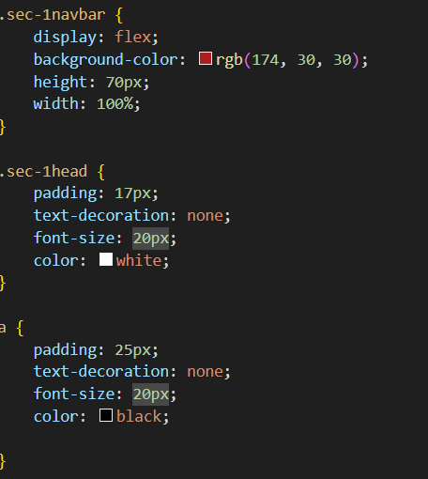

**Question** 5. What do you understand by CSS opacity?

**Answer.** CSS opacity sets the transparency level of an element from 0 (fully transparent) to 1 (opaque). Opacity is used for creating visual effects such as fading, blending or overlaying.

**Question** 6. How can the background color of an element be changed?

**Answer.** You can change the background color of an HTML element using the background-color CSS property and giving it a value of a color. With this code, the paragraphs are given black ,blue, pink , green, background.

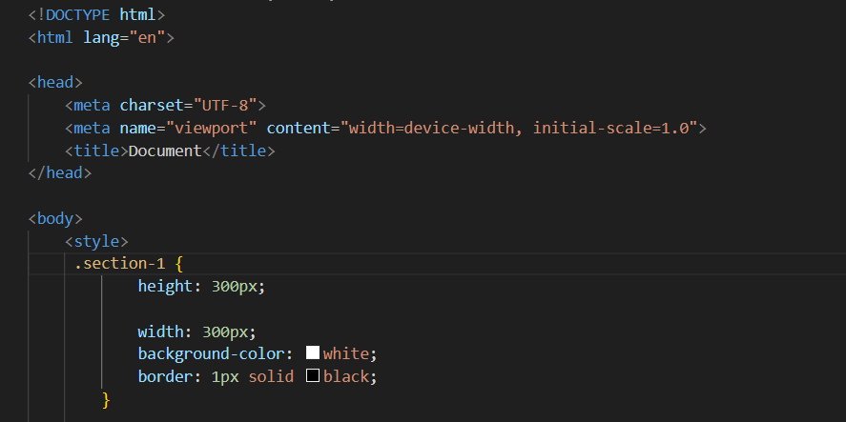

**Question** 7. How can image repetition of the backup be controlled?

**Answer**. This task can be achieved by using the background-repeat property which will help us control the repetition of the image. It also decides whether the background image will be repeated or not. background-repeat: no-repeat;

**Question** 8. What is the use of the background-position property?

**Answer**. The background-position property sets the starting position of a background image. Tip: By default, a background-image is placed at the top-left corner of an element, and repeated both vertically and horizontally.

    background: url(Place\ Your\ Image\ Here\ \(Double\ Click\ to\ Edit\)\ \(5\).png);

**Question** 9. Which property controls the image scroll in the background?

**Answer**. CSS property "background-attachment" controls the image scroll in the background. It has three values, scroll, fixed or local.

**Question** 10. Why should background and color be used as separate properties?

**Answer**. Background property is complex that can set multiple aspects of the background, such as image, position, size, repeat, etc. Color property is simple that can only set the text color. Combining them would make the syntax more complicated and confusing.

Q11. How to center block elements using CSS1?

**Answer**. Center block elements using margin property: We need to specify the margin from left and right such that it looks centered. We do not need to do this manually, we have one property value “auto” which will automatically set the margin such that our block element is placed in the center.

**Question** 12. How to maintain the CSS specifications?**Answer**. The CSS specifications are maintained by the World Wide Web Consortium (W3C). Even though every browser supports CSS, there are many inconsistencies in the supported specification version.

**Question** 13. What are the ways to integrate CSS as a web page?**Answer**. CSS can be added to HTML documents in 3 ways: Inline - by using the style attribute inside HTML elements. Internal - by using a <style> element in the <head> section.

**Question** 14. What is embedded style sheets?

**Answer**. Embedded style sheets are a way of applying CSS styles to an HTML document by using <style> element in <head> section. It useful for styling a document that has unique style requirements.

**Question** 15. What are the external style sheets?

**Answer**. External style sheets are files that contain CSS rules that can be applied to multiple HTML pages. External style sheets have css extension and are linked to HTML documents using <link> element in <head> section.

Q16. What are the advantages and disadvantages of using external style sheets?

**Answer**.

Advantages:

They improve maintainability and code organization, as you can edit the style of multiple pages from one file.They enhance reusability across multiple HTML files. We can link the same style sheet to different pages.ell Check

Disadvantages:

They may cause pages to not render correctly until the external style sheet is loaded. They may increase the site's download time.

Q17. What is the meaning of the CSS selector?

**Answer**. A selector can be based on the element name, id, class, attribute, pseudo-class, pseudo-element, or a combination of these. A selector is followed by a declaration block that contains the CSS properties and values to apply to the selected elements.

Q18. What are the media types allowed by CSS?

**Answer**.The all the media types devices.

The print media type, target print preview mode or when we try to print a web page.

The screen media type ,is used for computer screens, tablets phone and other display devices .it is

Most common media type for styling web pages.

Q19. What is the rule set?

**Answer**. CSS rule set contains one or more selectors and one or more declarations. The selector(s), which in this example is h1 , points to an HTML element. The declaration(s), which in this example are color: blue and text-align: center style the element with a property and value.

Q20. Create Layouts

**Answer**.

